- Welcome and check-in:
Attendees:
Paul Midgley (PM) (chair), Tammie Daly (TD), Tom Wedgewood (TW), Mike Prior (MP), John Prestage (JP) (part), Christine Jones (CJ)

- Apologies for absence: Anne Toler (AT), Linda Lowne (LL), Stephen Duckworth was welcomed as a new member but was unable to attend this meeting. Rob Reeve (RR) sadly has had to postpone joining the PPG due to work commitments. Nikki Lucas who was going to present an agenda item was unable to attend

- Approve Minutes from the last meeting:
Minutes of the last meeting held on the 5th April 2018 approved.
Actions arising from that meeting:
- LL – to send pen profiles to Paul – still outstanding
- LL to update group on recruitment of a young person to the PPG - outstanding
- MP & RR to review slides for the TV including highlighting the 111 service and to include the Let’s Live Well in Rushcliffe and what services are no longer qavailable on the NHS. What is and is not available on the NHS – MP and RR met and updates the slides. However the TV software is being upgraded so unable to alter the slides at this time.
- WB PPG chairs to have Active Group pre-meets to agree plans for pan-WB initiatives for the forth coming year. PM stated the chairs of the WB PPG had been emailing to collaborate better. WB Wire included a news item about how patients could contribute with their PPGs.
- NAPP conference. The practice kindly agreed to fund 2 PPG members to attend. Feedback will be supplied to both the practice and PPG
- PPG awareness week. The Sub group met on 11th April. PPG Awareness week not considered a priority but they looked and successfully completed the online registration and EPS which JP had flagged as a priority. Decision on communicating this more widely to patients overridden by GDPR requirements to get signature. See below.

- PartnersHealth including extended hours and weekend service
Unfortunately Nikki Lucas has had to postpone her talk until the next meeting. It is not for ongoing issues but acute problems.

- Feedback from Online Registration/e-prescribing task group meeting
The practice would prefer patients to come into reception to register as a signature is required. There is a problem for patients who share an email account with their partner. In these cases one person will have to have new email address.

- Updates from NAPP NHS England, GNTP, Principia MCP/PartnersHealth, Rushcliffe CCG Active Group & Patient Cabinet, Castle PPG

  - Rushcliffe Patient Conference feedback from today

PartnersHealth to look at publicing Patient code of Conduct/responsibility deal (utilitarian concept). If nothing produced by December it will be covered as an agenda item at that meeting.

STP changing into a Notts integrated care system, and will have its own budget.
Greater Nottingham and mid Notts work independently. Mid Notts have ICP (partnership provider). Greater Nottingham ICP is an alliance provider
At Rushcliffe level will be local integrated care partnership (with City, Nottm West and Nottm East and Social care). See diagram below:
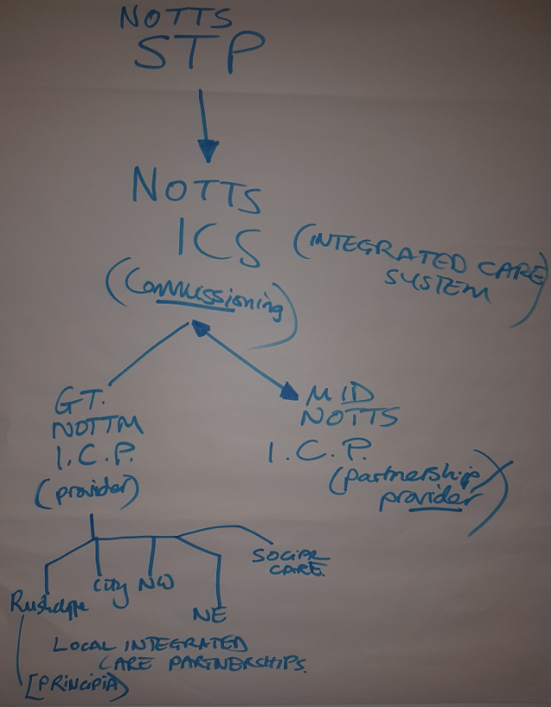

  - NAPP conference in Nottingham 9th June.
Will provide feedback at the next weekend

- Update on PPG Awareness week activities 4-9th June – WB Wire, Gresham Marshes,etc
Want to revamp Gresham Marsh as it’s a wildlife haven. Could it be linked to Lets Live Well in Rushcliffe and the Walking Group led by Jeremy Pratt? To be discussed jointly with CASTLE PPG.
WB Wire have already put an article about PPG Awareness Week on the WBW website this week and discussion took place as to further useful articles that could be included via a regular drip feed.

- Recruitment to PPG/virtual PPG - young person/young parent/special advisor/others
Some workshops are being held at the NAPP conference on how to engage young people – MP and PM will give feedback at next meeting. MP has a contact at the Beckett School to see if they can offer any ideas on how we could recruit a young person

- Correspondence/patient feedback/Friends & Family Test
Very few complaints received within the last year. Nothing highlighted on FFTs

- Summary of Actions agreed & key messages for Virtual PPG members, Practice TV, NHS Rushcliffe CCG Active/Patient Cabinet, WB Wire

Actions:
- LL – to send pen profiles to Paul
- LL to update group on recruitment of a young person to the PPG
- PartnersHealth looking at Patient code of Conduct. If nothing produced by December PM to put it as an agenda item.
- NAPP conference in Nottingham 9th June. MP and PM will provide feedback at the next meeting including the workshops on how to engage young people
- MP has contact at Beckett School to see if they can offer any ideas on how to recruit a young person
- PM to delete RR profile
- CJ will inform us when Numed have updated software.
- MP to add bit more on the out of hours for TV screen and on line access via reception
- PM to contact CASTLE PPG re Gresham Marshes project/CJ to liaise with the Lets Live Well in Rushcliffe coordinator who now works out of Embankment PC

- Check Out, close and depart

Next meeting:
- Extended hours and weekend service by Nikki Lucas.
- NHS health checks promotion
- Dementia Friends overview
- Flu clinics preparation/PPG input/aligned activities

Potential future topics to consider:
Antimicrobial Stewardship
Supporting the Self Care agenda
Disease focus e.g. Tele-dermatology, other PartnersHealth local service development initiatives
Patient self-help groups e.g. Dementia, Diabetes, Mental Health – publicise on Practice TV
Health Hub for Embankment PC Centre

Proposed dates of 2018 meetings –18.00 on Aug 2nd, Oct 4th, Dec 6th (AGM)

